# PYTHONANYWHERE

Submitted in partial fulfillment of the requirements for the award of

Bachelor of Engineering degree in Computer Science and Engineering By

### Student name: Gondrala Saicharan

**RegNo.:42110388**



### DEPARTMENT OF COMPUTER SCIENCE AND ENGINEERING

**SCHOOL OF COMPUTING**

**SATHYABAMA**

### INSTITUTE OF SCIENCE AND TECHNOLOGY (DEEMED TO BE UNIVERSITY)

**Accredited with Grade “A++” by NAAC JEPPIAAR NAGAR, RAJIV GANDHISALAI, CHENNAI – 600119**

### OCTOBER – 2023

**SATHYABAMA**

INSTITUTE OF SCIENCE AND TECHNOLOGY

### (DEEMED TO BE UNIVERSITY)

Accredited with “A++” grade by NAAC

Jeppiaar Nagar, Rajiv Gandhi Salai, Chennai – 600 119 [www.sathyabama.ac.in](http://www.sathyabama.ac.in/)

### DEPARTMENT OF COMPUTER SCIENCE AND ENGINEERING

**BONAFIDE CERTIFICATE**

This is to certify that this Product Report is the bonafide work of **Gondrala Saicharan (Reg.No- 42110388)** who carried out the Design entitled “**PYHONANYWHERE**” under my supervision from July 2022 to November 2023.

### Design Supervisor

### Ms.Dharani V M.E

**Head of the Department**

**Dr. L. LAKSHMANAN, M.E., Ph.D.**

### Submitted for Viva voice Examination held on

**Internal Examiner External Examiner**

### DECLARATION

I, **Gondrala Saicharan (Reg.No-42110388),** hereby declare that the Product Design Report entitled “**PYTHONANYWHERE**” done by me under the guidance of **Supervisor Ms.Dharani V M.E** , is submitted in partial fulfilment of the requirements for the award of Bachelor of Engineering degree in Computer Science and Engineering .

### DATE: / /2023

**PLACE: Chennai SIGNATURE OF THE CANDIDATE**

### ACKNOWLEDGEMENT

I am pleased to acknowledge my sincere thanks **to Board of Management of SATHYABAMA** for their kind encouragement in doing this project and for completing it successfully. I am grateful to them.

I convey my thanks **to Dr. T.Sasikala M.E., Ph. D, Dean**, School of Computing, **Dr. L.Lakshmanan M.E., Ph.D.,** Head of the Department of Computer Science and Engineering for providing me necessary support and details at the right time during the progressive reviews.

I would like to express my sincere and deep sense of gratitude to my Design Supervisor **Ms.Dharani V M.E**, for his valuable guidance, suggestions and constant encouragement paved way for the successful completion of project work.

I wish to express my thanks to all Teaching and Non-teaching staff members of the **Department of Computer Science and Engineering** who were helpful in many ways for the completion of the project.

|  |  |  |
| --- | --- | --- |
|  | **TABLE OF CONTENTS** |  |
| **Chapter No** | **TITLE** | **Page No.** |
| **1** | **ABSTRACT**  **INTRODUCTION** | 9  **10** |

### 

1. EXISTING SYSTEM 11
2. LIMITATIONS OF THE EXISTING SYSTEMS 12
3. PROPOSED SYSTEM 13,14
4. WEBSITE LOGO 15
5. CONTENTS OF PROJECT 16,17,18,19
6. CONCLUSION 20
7. REFERENCE 20
8. PROJECT SHAPSHOTS 21,22
9. SOURCE CODE 23 to 32
10. SLIDESHOW IMAGES 33

|  |
| --- |
|  |

**LIST OF FIGURES**

|  |  |  |
| --- | --- | --- |
| **Figure No.** | **Figure Name** | **Page No.** |
| **1** | Home page screenshot | 18 |
| **2** | Courses screenshot | 18 |
| **3** | Mobile view | 19 |
| **4** | Code screenshot | 19 |
| **5** | Slide show images | 33 |
| **6** |  |  |

# ABSTRACT

Python Anywhere is an innovative online platform dedicated to simplifying the process of learning Python programming. With a commitment to accessibility and excellence, Python Anywhere offers free, unrestricted access to a wealth of Python learning resources.

Our platform boasts a comprehensive library of video tutorials, supported by real-world examples, ensuring that learners can grasp Python's intricacies with ease. What sets Python Anywhere apart is its dedication to interactivity; users can practice their skills on the site's interactive coding platform, gaining hands-on experience and immediate feedback.

Community engagement is at the heart of Python Anywhere. Join a vibrant network of Python enthusiasts, ask questions, and share knowledge to enhance your learning journey. Our content remains current, keeping pace with the ever-evolving Python ecosystem.

Unlike other systems, Python Anywhere eliminates barriers, including the need for registration or subscription fees. Learning Python has never been this accessible.

Python Anywhere invites you to embark on a Python adventure, from beginner to expert. Dive into the world of Python today and discover the limitless possibilities this programming language has to offer.

# 1.INTRODUCTION

Welcome to Python Anywhere - Your Free Python Learning Resource!

Are you eager to learn Python, one of the most versatile and widely-used programming languages in the world? Look no further! Python Anywhere is your go-to destination for Python education, and the best part? No login or registration required. We believe in making Python learning accessible to everyone, like a free bird soaring in the open sky.

Why Python Anywhere?

Video Tutorials: Our library of video tutorials covers Python from the basics to advanced topics. Learn at your own pace, pause, rewind, and watch as many times as you need.

Real-World Examples: We understand that Python becomes more meaningful when you see it in action. That's why we provide real-world code examples that help you grasp concepts faster.

No Barriers: Forget about tedious sign-up processes or membership fees. Python Anywhere is open to all, from beginners to experienced programmers, without any restrictions.

Interactive Coding: Practice what you learn with our interactive coding platform. Write and run Python code right on the website, and see the results instantly.

Start Your Python Journey Today

Whether you're looking to kickstart your programming career, enhance your skills, or simply explore the world of Python, Python Anywhere is the perfect place to begin. We believe that Python should be accessible to everyone, and that's why we've created a no-barriers platform for your learning pleasure.

So, what are you waiting for? Dive into the fascinating world of Python with Python Anywhere. Let's spread the wings of knowledge together!

Feel free to use this introduction as a starting point for your website, and customize it further to fit your vision and mission for Python Anywhere. Happy coding!

# 2.Existing System

# Before the inception of "Python Anywhere," aspiring Python learners had limited options for structured online education. The existing landscape consisted of scattered resources across various platforms, including YouTube tutorials, text-based documentation, and a few online courses. This fragmented approach often left learners feeling overwhelmed and lacking a clear path to mastering Python.

# Challenges of the Existing System

# 1. Fragmented Learning: Learners had to navigate multiple platforms and sources to access Python tutorials and quizzes, leading to a disjointed learning experience.

# 2. Quality Variation: The quality of available Python tutorials varied widely, making it difficult for learners to distinguish between reliable and subpar resources.

# 3. Lack of Interactivity: The existing system lacked interactive elements such as quizzes or exercises, making it harder for learners to apply their knowledge and track their progress.

# 3.LIMITATIONS OF THE EXISTING SYSTEMS

# Cost and Restrictions: The existing system might have subscription fees, limited free access, or other restrictions that could discourage some users.

# Ease of Use: The existing system may have a steeper learning curve or a less intuitive interface.

# Interactive Learning: The existing system may lack interactive coding features, making it harder for users to apply what they've learned.

# Accessibility: The existing system may require users to create accounts or pay for access, potentially creating barriers for beginners or those looking for free resources.

# 4.PROPOSED SYSTEM

# Introduction

# Python Anywhere is a groundbreaking platform designed to revolutionize the way people learn Python programming. With an integrated approach of video tutorials and interactive quizzes, Python Anywhere aims to provide a seamless and comprehensive learning experience.

# Key Features

# 1. Structured Learning Path: Python Anywhere offers a structured curriculum that takes learners from Python basics to advanced topics. This clear roadmap ensures learners build a solid foundation and progress methodically.

# 2. High-Quality Videos: The platform hosts high-quality video tutorials delivered by experienced Python instructors. These videos are designed to be engaging and informative, making complex concepts accessible to all.

# 3. Community Engagement: Python Anywhere fosters a supportive community of Python enthusiasts. Learners can interact with peers, ask questions, and collaborate on projects, creating a collaborative learning environment.

# 4. 24/7 Accessibility: Python Anywhere is accessible 24/7, allowing learners to study at their own pace, whenever and wherever they prefer.

# Advantages of Python Anywhere

# - Streamlined Learning: Python Anywhere simplifies the learning process by offering a one-stop platform for Python education.

# 

# - Consistency: Learners can trust Python Anywhere for consistently high-quality content and a structured learning path.

# - Engagement: The combination of videos and examples keeps learners engaged and actively involved in the learning process.

# - Community: Python Anywhere fosters a sense of community, providing learners with support and networking opportunities.

# In conclusion, "Python Anywhere" represents a significant improvement over the fragmented existing system, offering a holistic and effective approach to learning Python through videos and quizzes. It empowers learners to build their Python skills systematically and interactively while being part of a supportive community.

# WEBSITE LOGO:

# 

# CONTENTS OF THE PROJECT: Home Page:

# The home page serves as the main landing page of your website. It provides an introduction to your website and its purpose. This page may include highlights of the courses offered, key features, and a call to action to encourage visitors to explore further.

# About Page:

# The About page offers more information about your website. It describes the website's mission, goals, and what users can expect to find. It might also include information about the creators or team behind the website.

# Courses:

# The Courses section of your website is where users can explore the different levels of Python courses offered. There are three levels:

# Beginner Level: This course is designed for those who are new to Python programming. It may include topics like basic syntax, data types, and simple programming concepts.

# Intermediate Level: The Intermediate course is for users with some Python experience. It covers more advanced topics such as functions, libraries, and data manipulation.

# Advanced Level: The Advanced course is for experienced Python programmers. It delves into complex concepts like object-oriented programming, web development, and advanced data analysis.

# Contact Page:

# The Contact page provides users with a way to get in touch with your website. It typically includes a contact form or a visible email address where users can send inquiries, feedback, or questions.

# This structure should give visitors a clear understanding of your website's purpose, the courses available, and how to reach out for further information. Of course, you can add additional details and design elements to make each page more engaging and informative.

# 

# Creating Seamless Web Navigation:

# We harnessed the power of web routing to seamlessly connect every page of our website, ensuring a fluid and intuitive user experience. With a simple click, users can effortlessly explore various sections, making navigation a breeze.

# Visual Impact with Stunning Imagery:

# To captivate and engage our viewers, we didn't stop at just content. We've adorned our website with a curated collection of striking photos and visuals. Each image is carefully selected to create an aesthetically pleasing and visually impressive environment, enhancing the overall user experience.

# Interactive Design for Engaging User Experience:

# Our website isn't just a static platform; it's a dynamic and interactive space. We've designed it with you in mind, making it easy for you to interact, explore, and engage. You'll find interactive elements that respond to your actions, creating an immersive journey through our content.

# Empowering Learning with Real-World Examples:

# To ensure that our concepts are crystal clear and accessible to all, we've strategically placed real-world examples right in the heart of our content. These examples provide a tangible and practical understanding, making complex ideas easier to grasp. Learning becomes a hands-on experience, promoting better comprehension.

# So, welcome to our website, where web routing, captivating imagery, and interactive design come together to create an impressive and user-friendly environment. Dive in and explore the world of knowledge and learning with ease!

# 

# Taking Your Project to the World: Deploying on Netlify.com

# After crafting a stunning and interactive webpage, the next crucial step is to make it accessible to a global audience. We've entrusted this task to Netlify.com, a platform renowned for its seamless deployment and hosting capabilities.

# Effortless Deployment:

# Netlify.com simplifies the deployment process. With just a few clicks, we were able to take our locally developed project and deploy it to the cloud. This means that our webpage, once confined to our local environment, is now accessible from anywhere in the world with an internet connection.

# Global Accessibility:

# By hosting our webpage on Netlify, we've broken down geographical barriers. Whether you're in New York, Tokyo, or anywhere else on the planet, you can access our website without any hindrance. Netlify ensures low latency and fast loading times, ensuring a smooth experience for visitors worldwide.

# Our website link:

# https://pythonanywhere2023.netlify.app/

# 

# 5.CONCLUSION

# Python Anywhere is not just a website; it's a gateway to the world of Python programming. With our commitment to accessibility, high-quality content, interactive learning, and a thriving community, we've created a platform that empowers learners of all levels to master Python. Whether you're a complete beginner or an experienced coder, Python Anywhere is your free ticket to explore, learn, and excel in Python programming. Join us today, and together, let's embark on an exciting journey of discovery and innovation through the power of Python."

# 6.REFERENCE

# https://www.w3schools.com/

# https://chat.openai.com/

# https://www.youtube.com/results?search_query=jenny+lecture

# https://www.netlify.com/

# OUR PROJECT SNAPSHOTS

# 

# 

# 

# 

# Important Source code:

Slideshow code:  
  
<div class="slideshow-container">

        <div class="mySlides fade">

          <img src="photo-2.jpg" style="width:100%">

            <div class="text-container">

                <h2>Start Your Python Journey</h2>

                <p>Unlock the power of Python with our comprehensive courses.</p>

                <a href="#courses" class="btn">Explore Courses</a>

            </div>

        </div>

        <div class="mySlides fade">

          <img src="photo-3.jpg" style="width:100%">

          <div class="text-container">

            <h2>Start Your Python Journey</h2>

            <p>Unlock the power of Python with our comprehensive courses.</p>

            <a href="#courses" class="btn">Explore Courses</a>

        </div>

        </div>

        <div class="mySlides fade">

          <img src="photo.jpg" style="width:100%">

          <div class="text-container">

            <h2>Start Your Python Journey</h2>

            <p>Unlock the power of Python with our comprehensive courses.</p>

            <a href="#courses" class="btn">Explore Courses</a>

        </div>

        </div>

        </div>

        <br>

        <div style="text-align:center">

            <span class="dot"></span>

            <span class="dot"></span>

            <span class="dot"></span>

          </div>

Navbar code:

<header>

        <div class="container" >

            <h1>Welcome to Python Any Where</h1>

            <nav>

                <ul>

                    <li><img src="PAW.png"  style="width:110px;height:110px;"></li>

                    <li><a href="index.html">Home</a></li>

                    <li><a href="about.html">About</a></li>

                    <li><a href="courses.html">Courses</a></li>

                    <li><a href="#contact">Contact</a></li>

                </ul>

            </nav>

        </div>

    </header>

Slideshow js code:

<script>

        let slideIndex = 0;

        showSlides();

        function showSlides() {

          let i;

          let slides = document.getElementsByClassName("mySlides");

          let dots = document.getElementsByClassName("dot");

          for (i = 0; i < slides.length; i++) {

            slides[i].style.display = "none";

          }

          slideIndex++;

          if (slideIndex > slides.length) {slideIndex = 1}

          for (i = 0; i < dots.length; i++) {

            dots[i].className = dots[i].className.replace(" active", "");

          }

          slides[slideIndex-1].style.display = "block";

          dots[slideIndex-1].className += " active";

          setTimeout(showSlides, 2000); // Change image every 2 seconds

        }

        </script>

About Section Code:

<section id="about" class="bg-gray">

        <table border="0" id="about" width="100%" cellpadding="0" cellspacing="0" bgcolor="#bfbdbd">

            <tr>

                 <td>

                     <table border="0" width="85%" cellpadding="15" cellspacing="0" align="center">

                         <!-- Heading Start-->

                     <tr>

                           <td height="160" align="center" valign="middle" colspan="2">

                                <font face="arial" size="6" color="black">

                                  About

                               </font>

                               <hr width="70" color="black">

                           </td>

                     </tr>

                     <!-- Heading  End-->

                     <tr>

                            <td width="35%">

                                  <img src="python.png" width="100%" alt="about" />

                            </td>

                            <td width="65%" valign="top">

                                  <table border="0" width="100%" cellpadding="0" cellspacing="0" align="center">

                                        <tr>

                                             <td>

                                                 <font face="arial" size="5" color=" #000000">

                                                Python Anywhere<br>

                                                </font>

                                            </td>

                                        </tr>

                                        <tr>

                                            <td>

                                                <br>

                                            </td>

                                        </tr>

                                        <tr>

                                            <td>

                                                <p>

                                                    <font face="arial" size="3" color="#000000">

                                                        Python is a high-level, general-purpose programming language. Its design philosophy

                                                        emphasizes code readability with the use of significant indentation.

                                                        Python is dynamically typed and garbage-collected. It supports multiple programming paradigms,

                                                        including structured (particularly procedural), object-oriented and functional programming.

                                                        It is often described as a "batteries included" language due to its comprehensive standard library.

                                                        Python Anywhere is your dedicated online destination for learning Python programming.

                                                        Whether you're a novice just starting your coding journey or an experienced developer

                                                        looking to sharpen your Python skills, our platform offers a comprehensive and accessible

                                                         learning experience.Dive into Python coding immediately with our user-friendly, browser-based

                                                         coding environment. No need for installations or downloads; just open your web browser and start coding.

                                                         We believe in a quiz-free, pressure-free learning environment. Learn Python for the joy of programming

                                                         and creativity, not for the sake of exams.Enjoy the freedom to learn Python without the constraints of

                                                          program tracking. Explore topics that interest you the most without any predefined learning path.

                                                </font>

                                                </p>

                                                <hr noshade>

                                                <br/>

                                            </td>

                                        </tr>

                                  </table>

                            </td>

                     </tr>

                    <!-- section padding bottom -->

                     <tr>

                           <td height="60" colspan="2">

                           </td>

                     </tr>

                    <!-- section padding bottom End-->

                  </table>

                </td>

             </tr>

          </table>

          <!-- End About -->

                    </td>

                  </tr>

                  <!-- section padding bottom -->

                     <tr>

                           <td height="60" colspan="3">

                           </td>

                     </tr>

                    <!-- section padding bottom End-->

                  </table>

               </td>

             </tr>

          </table>

    </section>

Course Section code:

<section id="courses">

        <div class="container">

            <h2>Python Courses</h2>

            <div class="course">

                <h3>Beginner Python</h3>

                <p>Get started with the fundamentals of Python programming. This course is designed for beginners with no prior programming experience. Topics covered include:</p>

                <ul>

                    <li>Introduction to Python</li>

                    <li>Variables and Data Types</li>

                    <li>Conditional Statements</li>

                    <li>Loops</li>

                    <li>Functions</li>

                </ul>

                <a href="Beginner.html" class="btn">Start Now</a>

            </div>

            <div class="course">

                <h3>Intermediate Python</h3>

                <p>Take your Python skills to the next level with our intermediate course. Topics covered include:</p>

                <ul>

                    <li>Lists and Dictionaries</li>

                    <li>File Handling</li>

                    <li>Error Handling</li>

                    <li>Modules and Packages</li>

                    <li>Object-Oriented Programming</li>

                    <li>Database Connectivity</li>

                    <li>Web Scraping</li>

                </ul>

                <a href="" class="btn">Comming Soon!</a>

            </div>

            <div class="course">

                <h3>Advanced Python</h3>

                <p>Master advanced topics in Python with our advanced course. Topics covered include:</p>

                <ul>

                    <li>Concurrency and Multithreading</li>

                    <li>GUI Programming</li>

                    <li>Data Science and Machine Learning</li>

                    <li>Web Development with Django</li>

                    <li>Deployment and Scaling</li>

                </ul>

                <a href="" class="btn"> Comming Soon!</a>

            </div>

        </div>

    </section>

Compiler demo code:

            <iframe src="https://trinket.io/embed/python3/6b624c642e" width="100%" height="356" frameborder="0" marginwidth="0" marginheight="0" allowfullscreen></iframe>

YouTube video demo code:

            <iframe width="560" height="315" src="https://www.youtube.com/embed/DInMru2Eq6E?si=jRCBmALfegM3O5AV" title="YouTube video player" frameborder="0" allow="accelerometer; autoplay; clipboard-write; encrypted-media; gyroscope; picture-in-picture; web-share" allowfullscreen></iframe>

Course menu code:

<section>

    <aside>

        <h2>Course Topics</h2>

        <ul class="topic-menu">

            <li><a href="Intro.html">Introduction to Python</a></li>

            <li><a href="variables.html">Variables and Data Types</a></li>

            <li><a href="conditional.html">Conditional Statements</a></li>

            <li><a href="loop.html">Loops</a></li>

            <li><a href="functions.html">Functions</a></li>

        </ul>

    </aside>

    </section>

Contact and footer code:

 <section id="contact" class="bg-gray">

        <div class="container">

            <h2>Contact Us</h2>

            <p>If you have any questions or need assistance, feel free to contact us.</p>

            <address>

                Email: <a href="mailto:contact@learnpython.com">contact@learnpython.com</a><br>

                Phone: +1 (123) 456-7890

            </address>

        </div>

    </section>

    <footer>

        <div class="container">

            <p>&copy; 2023 Learn Python</p>

        </div>

    </footer>

CSS code:

/* styles.css */

/* Reset some default styles */

body, h1, h2, h3, p, ul, li {

    margin: 0;

    padding: 0;

}

/* Basic styles for the website */

body {

    font-family: Arial, sans-serif;

}

.container {

    max-width: 1200px;

    margin: 0 auto;

    padding: 20px;

}

.container1{

    max-width: 1200px;

    margin: 0 auto;

    padding: 20px;

}

header {

    background-color: #333;

    color: #fff;

    padding: 20px 0;

}

nav ul {

    list-style: none;

}

nav li {

    display: inline;

    margin-left: 20px;

}

nav a {

    text-decoration: none;

    color: #fff;

    font-weight: bold;

    transition: color 0.3s;

}

nav a:hover {

    color: #ff6600;

}

section {

    padding: 60px 0;

    text-align: center;

    color: #333;

}

.cont {

    align-items: flex-end;

}

.bg-gray {

    background-color: #f4f4f4;

}

h2 {

    font-size: 2rem;

    margin-bottom: 20px;

}

p {

    font-size: 1.2rem;

    line-height: 1.6;

}

.btn {

    display: inline-block;

    padding: 10px 20px;

    margin-top: 20px;

    background-color: #ff6600;

    color: #fff;

    text-decoration: none;

    border-radius: 5px;

    font-weight: bold;

    transition: background-color 0.3s;

}

.btn:hover {

    background-color: #ff4500;

}

.course {

    background-color: #fff;

    padding: 20px;

    border-radius: 5px;

    box-shadow: 0 0 10px rgba(0, 0, 0, 0.1);

    margin: 20px;

    text-align: left;

}

footer {

    background-color: #333;

    color: #fff;

    text-align: center;

    padding: 10px 0;

}

aside {

    position: fixed;

    background-color: #d99971;

    padding: 20px;

    width: 20%;

    float: left;

}

.topic-menu {

    list-style: none;

    padding: 0;

    height:90vh;

}

.topic-menu li {

    margin: 10px 0;

}

.topic-menu a {

    text-decoration: none;

    color: #333;

    font-weight: bold;

    display: block;

    padding: 5px;

    border-left: 5px solid transparent;

    transition: background-color 0.3s, border-color 0.3s;

}

.topic-menu a:hover {

    background-color: #ff6600;

    border-left-color: #333;

}

.slideshow-container {

    max-width: 1200px;

    position: relative;

    margin: auto;

    color: #323233;

  }

/* Fading animation */

.fade {

    animation-name: fade;

    animation-duration: 1.5s;

    color: #323233;

  }

  @keyframes fade {

    from {opacity: .4}

    to {opacity: 1}

  }

  * {box-sizing: border-box;}

body {font-family: Verdana, sans-serif;}

.mySlides {display: none;}

img {vertical-align: middle;}

        .gfg {

            margin: 3%;

            position: relative;

        }

      /*This CSS code is defining the styles for a container that holds text*/

        .text-container {

            position:-webkit-sticky;

            color: rgb(255, 255, 255);

            left: 10rem;

            top: 10rem;

            background-color: rgb(41, 41, 41, 41);

            padding: 0 3rem 1rem;

        }

Slide show images:

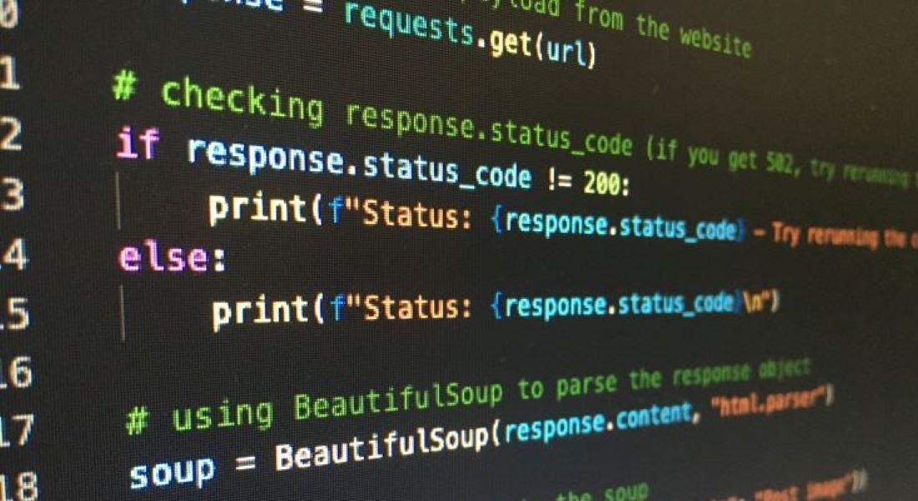



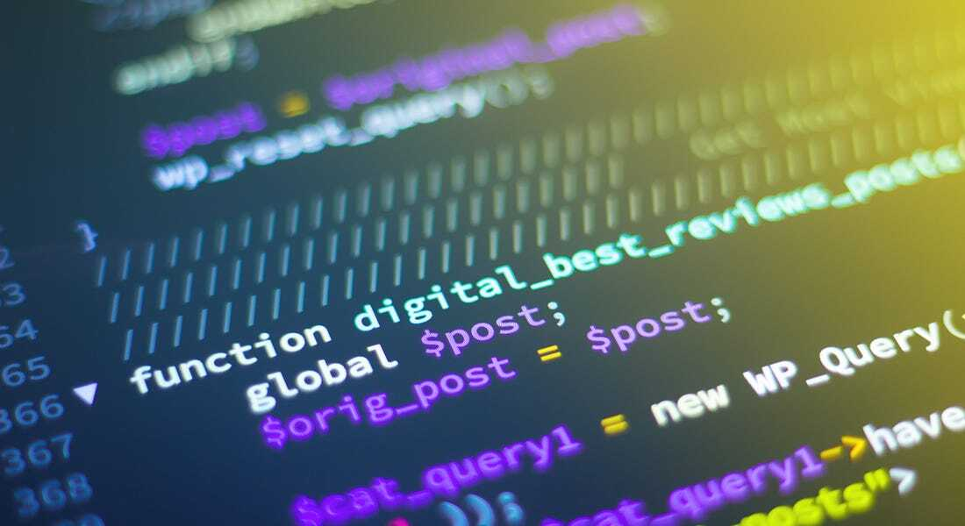

About image:

